CSE221
Lab Assignment 04
Fall 2023

Submission Guidelines :

- You can code all of them either in Python, CPP, or Java. But you should choose a specific language for all tasks.
- For each task write separate python files like task2.py, task3.py, and so on. For problems that have subproblems, name those like task1A.py, task1B.py, and so on.
- Add a hand written explanation of 3-4 lines for each of your solutions and submit that as a single document.
- For each problem, take input from files called "inputX_Y.txt" and output at "outputX_Y.txt", where X is the task number and Y is the sample i/o number. For example, for problem 2 sample 1, the input file is this, "input2_1.txt". For problems that have subproblems, name the files like "input1a_1.txt", "output1a_1.txt" and so on. Same for output.
- For each task include at least one input file (if any) in the submission folder.
- Finally zip all the files and rename this zip file as per this format:LabSectionNo_ID_CSE221LabAssignmentNo_Fall2023.zip [Example:LabSection01_21101XXX_CSE221LabAssignment05_Fall2023.zip]
- Don't copy from your friends.
- You MUST follow all the guidelines, naming/file/zipping convention stated above.
Failure to follow instructions will result in a straight 50% mark deduction.

A useful tool for making graphs:

https://csacademy.com/app/graph_editor/

You can find all the Input Files of this lab from here:

https://drive.google.com/drive/folders/10grRR3iRIfVn6kFLyD86-n8xQewUNU9n?usp=sharing

Task 01 (Graph Representation):

A) You are given a directed weighted Graph, G. The graph consists of N vertices and M edges. In this problem, you have to store the graph using Adjacency Matrix and print the matrix.

Input:

The first line contains two integers N and M (1 <= N, M <= 100) — the number of vertices and the total number of edges.
The next M lines will contain three integers u_{i}, v_{i,} and w_{i} (1 <= u_{i}, v_{i} <= N, 1 <= w_{i} <= 1000) — denoting there is an edge between node u_{i} and v_{i} with cost w_{i}.

Output:

You have to make the graph using Adjacency Matrix, and print the Adjacency Matrix in output.

Sample Input/Output:

Sample Input 1 | Sample Output 1
4 3  1 3 8  3 2 5  1 4 2 | 0 0 0 0 0  0 0 0 8 2  0 0 0 0 0  0 0 5 0 0  0 0 0 0 0
Sample Input 2 | Sample Output 2
6 7  1 5 6  6 3 5  1 3 9  3 4 7  4 6 1  5 6 8  6 1 6 | 0 0 0 0 0 0 0  0 0 0 9 0 6 0  0 0 0 0 0 0 0  0 0 0 0 7 0 0  0 0 0 0 0 0 1  0 0 0 0 0 0 8  0 6 0 5 0 0 0

B) Previously, we have learned how to represent a graph using the Adjacency matrix. Now in this problem, using the information in Task 01 (a), you have to build the graph using Adjacency List.

Sample Input/Output:

Sample Input 1 | Sample Output 1
4 3  1 3 8  3 2 5  1 4 2 | 0 :  1 : (3,8) (4,2)  2 :  3 : (2,5)  4 :
Sample Input 2 | Sample Output 2
6 7  1 5 6  6 3 5  1 3 9  3 4 7  4 6 1  5 6 8  6 1 6 | 0 :  1 : (5,6) (3,9)  2 :  3 : (4,7)  4 : (6,1)  5 : (6,8)  6 : (3,5) (1,6)
Sample Input 3 | Sample Output 3
9 15  1 9 4  8 7 5  5 4 7  4 3 2  2 1 10  3 1 15  7 1 13  3 9 8  3 8 4  3 7 3  5 3 1  5 8 2  9 4 8  9 2 10  9 2 12 | 0 :  1 : (9,4)  2 : (1,10)  3 : (1,15) (9,8) (8,4) (7,3)  4 : (3,2)  5 : (4,7) (3,1) (8,2)  6 :  7 : (1,13)  8 : (7,5)  9 : (4,8) (2,10) (2,12)

Brainstorming: [No need to submit the following questions]

- What if it was an undirected graph? Can you think of where you have to modify in your code for an undirected graph?

- In the last input of Task 01 (B), you notice there are two edges from node ‘9’ to node ‘2’ of cost 10 and 12, known as parallel edges. If a graph contains parallel edges, then can we represent the graph using Adjacency Matrix?

Task 02 (Graph Traversal Using BFS):

You have most probably heard of Dora The Explorer. She likes to travel from one country to another.

Currently, Dora is at Doraland. Doraland is a beautiful country, consisting of N cities and M bidirectional roads.

Recently, Dora has started to learn Graph Algorithms. She knows about BFS and DFS. However, since Dora is still learning, she is not feeling so confident and asks for your help.

Dora contacts you and gives you all the necessary information about Doraland. Dora will start her journey from city 1. Now, your task will be to help Dora to find a path which is similar to the path of BFS graph traversal.

Input

The given map will be an undirected and unweighted graph.
The first line contains two integers N and M (1 <= N, M <= 100) — the number of cities and the total number of roads.
The next M lines will contain two integers u_{i}, v_{i} (1 <= u_{i}, v_{i} <= N) — denoting there is a bidirectional road between u_{i} and v_{i}.

Output

Print the BFS path traversal which Dora will follow to explore the city, starting from city 1.

Sample Input 1 | Sample Output 1 | Sample Graph 1
4 3  1 3  3 2  1 4 | 1 3 4 2  ( Another valid path:  1 4 3 2 ) | 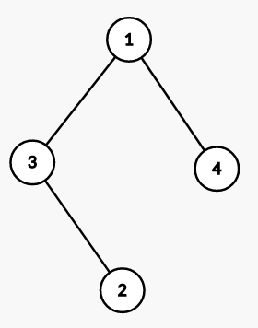
Sample Input 2 | Sample Output 2 | Sample Graph 2
7 7  1 3  3 2  1 4  2 5  5 6  1 7  7 6 | 1 3 4 7 2 6 5 | 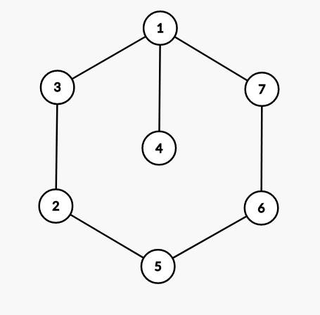
Sample Input 3 | Sample Output 3 | Sample Graph 3
9 8  1 2  1 3  1 4  2 5  4 6  4 7  6 8  3 9 | 1 2 3 4 5 9 6 7 8 | 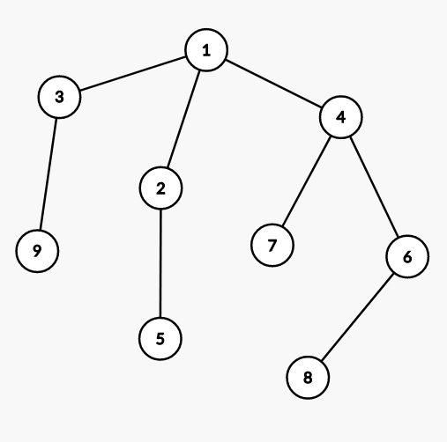
Sample Input 4 | Sample Output 4 | Sample Graph 4
11 14  1 2  1 3  10 4  2 5  4 6  4 7  6 8  3 9  3 7  1 8  4 8  1 10  9 11  10 11 | 1 2 3 8 10 5 9 7 6 4 11 | 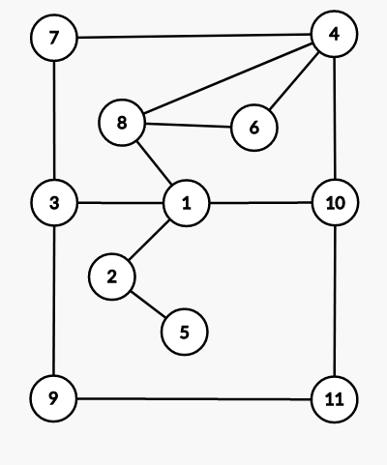

This problem may have multiple valid solutions, however your solution should follow the BFS level order traversal.

Pseudocode of BFS:

The breadth-first-search procedure BFS below assumes that the input graph G = (V, E) is represented using adjacency lists.

BFS(G,s):
1 for each vertex u in G.V:
2 u.colour = 0
3 Q = Ø ;
4 s.colour = 1
5 ENQUEUE(Q,s)
6 while Q ≠ Ø;
7 u = DEQUEUE(Q)
8 for each v in G.Adj[u]:
9 if v.colour == 0:
10 v.colour = 1
11 ENQUEUE(Q,v)

Task 03 (Graph Traversal Using DFS):

After successful BFS traversal, Dora wants to visit the whole country again. However, this time Dora wants to traverse the country following the path which is similar to the path of DFS graph traversal.

Yes, you guessed it correctly. You have to help Dora this time also.

The input format remains the same as Task 02. Dora will start her journey from city 1 again.

Input

The given map will be an undirected and unweighted graph.
The first line contains two integers N and M (1 <= N, M <= 100) — the number of cities and the total number of roads.
The next M lines will contain two integers u_{i}, v_{i} (1 <= u_{i}, v_{i} <= N) — denoting there is a bidirectional road between u_{i} and v_{i}.

Output

Print the DFS path traversal which Dora will follow to explore the city, starting from city 1.

Sample Input 1 | Sample Output 1 | Sample Graph 1
4 3  1 3  3 2  1 4 | 1 3 2 4  ( Another valid path:  1 4 3 2 ) | 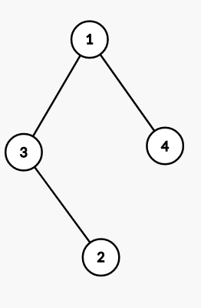
Sample Input 2 | Sample Output 2 | Sample Graph 2
7 7  1 3  3 2  1 4  2 5  5 6  1 7  7 6 | 1 3 2 5 6 7 4 | 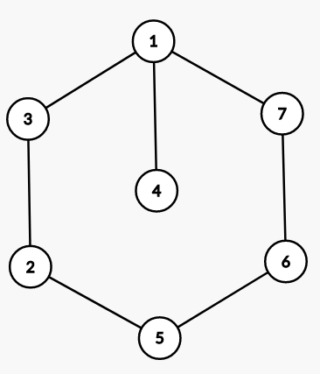
Sample Input 3 | Sample Output 3 | Sample Graph 3
9 8  1 2  1 3  1 4  2 5  4 6  4 7  6 8  3 9 | 1 2 5 3 9 4 6 8 7 | 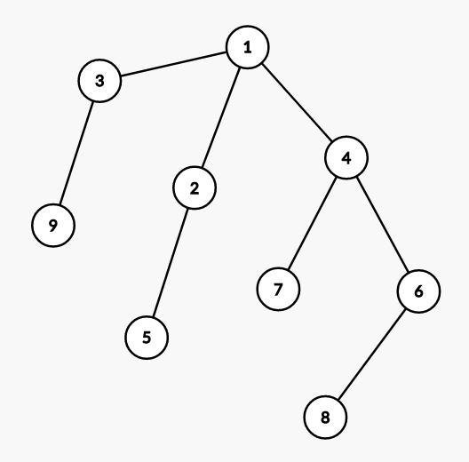
Sample Input 4 | Sample Output 4 | Sample Graph 4
11 14  1 2  1 3  10 4  2 5  4 6  4 7  6 8  3 9  3 7  1 8  4 8  1 10  9 11  10 11 | 1 2 5 3 9 11 10 4 6 8 7 | 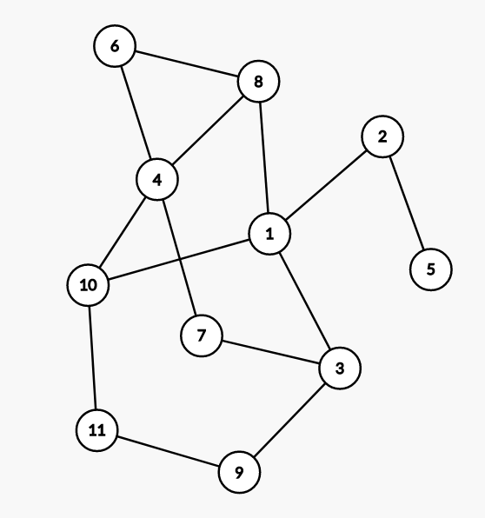

This problem may have multiple valid solutions. However, your solution should follow the dfs path traversal order.

Pseudocode of DFS:

The depth-first-search procedure DFS below assumes that the input graph G = (V, E) is represented using adjacency lists.

colourInitializing(G):
1 for each vertex u in G.V:
2 u.colour = 0
DFS(G,u):
1 u.colour = 1
2 for each v in G.Adj[u]:
3 if v.colour == 0:
4 DFS(G,v)

Task 04 (Cycle Finding):

It was a very hectic day for Dora. Before going to sleep, Dora wants to find out if there is any Cycle in the map of the city.

Since Dora has traveled the whole country twice, she is feeling very exhausted and asks you to solve the problem. However, Dora has made the roads of the cities directed in her map, so that you don’t get bored.

In graph theory, a cycle in a graph is a non-empty trail in which only the first and last vertices are equal. [Wikipedia]

Input:

The given map will be a directed and unweighted graph.
The first line contains two integers N and M (1 <= N, M <= 100) — the number of cities and the total number of roads.
The next M lines will contain two integers u_{i}, v_{i} (1 <= u_{i}, v_{i} <= N) — denoting there is a bidirectional road between u_{i} and v_{i}.

Output:

Print “YES” if the map contains any Cycle, otherwise print “NO”.

Sample Input 1 | Sample Output 1 | Sample Graph 1
4 3  1 3  3 2  1 4 | NO | 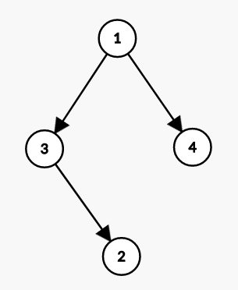
Sample Input 2 | Sample Output 2 | Sample Graph 2
4 4  3 1  3 2  1 4  4 3 | YES | 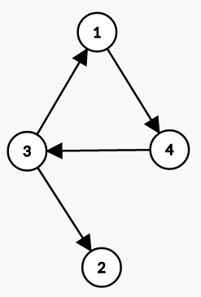
Sample Input 3 | Sample Output 3 | Sample Graph 3
4 4  1 3  3 2  1 4  4 3 | NO | 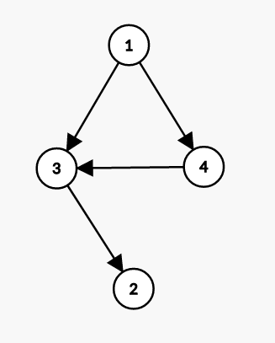
Sample Input 4 | Sample Input 4 | Sample Graph 4
9 10  1 2  2 3  3 4  4 5  3 5  1 6  2 7  5 8  5 9  8 9 | NO | 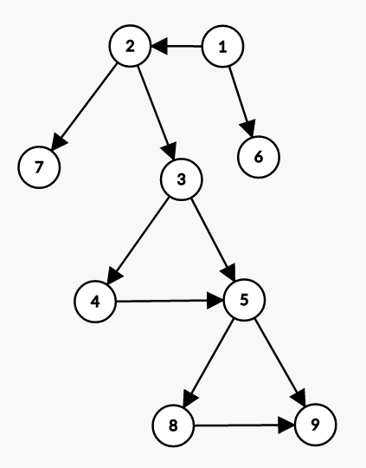
Sample Input 5 | Sample Input 5 | Sample Graph 5
5 7  1 2  2 3  1 3  3 4  4 5  3 5  4 2 | YES | 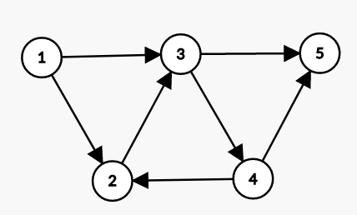

Brainstorming: [No need to submit the following questions]

- Suppose that you have an undirected and unweighted graph, can you find out if the given graph is a tree or not?

- Suppose that you have an undirected and unweighted graph. Can you find out if the graph contains an Odd length Cycle? An odd length cycle means the cycle will contain odd numbers of vertices.

Task 05 (Find the shortest path):

The next day, Dora again called you for helping her. Among all the cities she likes city 'D' the most.

Since you are becoming very much annoyed with Dora, you have planned to reach city D spending the minimum amount of time.

In the belugaland, moving between two cities connected by a road takes one second. You have to find the minimum time to reach D and show the path in the output.

Dora and you will start your journey from city 1.

Input

The given map will be an undirected and unweighted graph.
The first line contains three integers N, M, and D (1 <= N, M, D <= 100) — the number of cities, the total number of roads and the destination city.
The next M lines will contain two integers u_{i}, v_{i} (1 <= u_{i}, v_{i} <= N) — denoting there is a bidirectional road between u_{i} and v_{i}.

Output

Print the minimum amount of time to reach city D from city 1. Next, print the shortest path you will follow.

Sample Input 1 | Sample Output 1
4 3 2  1 3  3 2  1 4 | Time: 2  Shortest Path: 1 3 2
Sample Input 2 | Sample Output 2
6 6 5  1 3  3 2  1 4  2 6  5 6  4 6 | Time: 3  Shortest Path: 1 4 6 5
Sample Input 3 | Sample Output 3
9 8 7  1 2  1 3  1 4  2 5  4 6  4 7  6 8  3 9 | Time: 2  Shortest Path: 1 4 7
Sample Input 4 | Sample Output 4
11 14 5  4 2  1 3  10 4  2 5  4 6  4 7  6 8  3 9  3 7  1 8  4 8  1 10  9 11  10 11 | Time: 4  Shortest Path: 1 8 4 2 5
Sample Input 5 | Sample Output 5
4 3 1  1 3  3 2  1 4 | Time: 0  Shortest Path: 1

This problem may have multiple valid shortest paths. However, the minimum time required to reach the destination should be matched exactly with the output.

Task 06 (Flood Fill):

Dora is leaving the country. Before leaving the country, as a token of gesture, Dora gifted you with a map of the jungle “Jumanji”.

The map is very interesting. The map is a 2D grid. Some of those cells are occupied by diamonds and obstacles. [See the Sample input for better understanding.]

Now, you are on a journey to Jumanji in search of Diamonds. However, since the jungle is full of ferocious creatures, you can’t collect all the diamonds. You will choose only one start position such that you collect the maximum amount of diamonds.
Please note that you can not move to any cell which contains obstacles.

Input

The first line contains two integers R and H (1 <= R, H <= 100) — the number of rows and columns respectively in the grid.

The next R line will contain H characters. Each character represents the status of a cell as follows.

- '.': Empty Cell → You can move here.
- 'D': Cell with a Diamond → If you move to the cell containing ‘D’, you will collect that Diamond.
- '#': Cell with an obstacle → You can’t move to this cell.

Output

Print a single integer that denotes the maximum amount of Diamonds you can collect.

[The diamonds are coloured red to demonstrate which diamonds have been collected.]

Sample Input 1 | Sample Output 1
4 3  ..D  D..  .D.  ##. | 3
Sample Input 2 | Sample Output 2
10 7  ...#..D  ...#D..  D..#.D.  D..#...  DDD####  .......  .####..  .#D.#DD  .####..  DDD...D | 11
Sample Input 3 | Sample Output 3
9 11  .#..D...D..  .#.#######.  D#.#..D..#.  D#D#.###.#D  .#.#..D#.#.  .#.#####.#D  D#..D...D#.  .#########.  ...D..D...D | 15
Sample Input 4 | Sample Output 4
5 5  .....  ####.  #D.#.  ####.  ..... | 1
Sample Input 5 | Sample Output 5
5 5  .....  ####.  #..#.  ####.  ..... | 0
Sample Input 6 | Sample Output 6
1 5  D.... | 1
Sample Input 7 | Sample Output 7
12 12  ............  .####.......  .#D.#.......  .####.......  ........###.  ...D....#D#.  ........#D#.  .########D#.  .#D....##.#.  .#.D..D##D#.  .##########.  ............ | 4

Bonus Tasks: Task 07 and Task 08 [5+5 = 10 Points]

Note that these are bonus problems. Even if you do not attempt these problems, you can get a perfect score. So, do not worry if you find it too hard!

The faculty may ask you viva for these problems. If you are unable to give a correct explanation, you will receive 0 in this lab.

Bonus 1: Task 07:

Dora returns to Doraland once again. She finds that the city has undergone significant improvements since her last visit. The city structure has been reconstructed to make it more beautiful. Currently, Doraland consists of N cities and all the cities are connected with N-1 bidirectional roads.

However, this time, Dora will have a very short trip and as usual, she seeks your help. According to Dora’s wish, you will choose two cities, let’s say city A and city B in such a way that while traveling from city A to city B Dora can pass through a maximum number of cities. You have to keep in mind that it is not possible to visit any roads twice in the journey since Dora is on a short trip.

Can you help Dora find such two cities?

Input

The given map will be an undirected and unweighted graph.
The first line contains one integer N (2 <= N <= 100) — the number of cities.
The next N-1 lines will contain two integers u_{i}, v_{i} (1 <= u_{i}, v_{i} <= N) — denoting there is a bidirectional road between u_{i} and v_{i}.

Output

Print two cities A and B which satisfy the conditions stated in the problem statement.

Sample Input 1 | Sample Output 1 | Sample Graph 1
5  4 1  4 2  1 3  4 5 | 2 3  Or ( 3 5 )  [You may print only one valid output] | 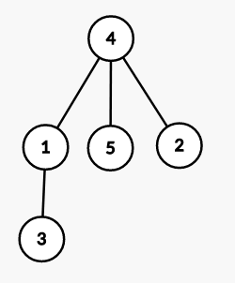
Sample Input 2 | Sample Output 2 | Sample Graph 2
6  4 1  4 2  1 3  4 5  2 6 | 3 6 | 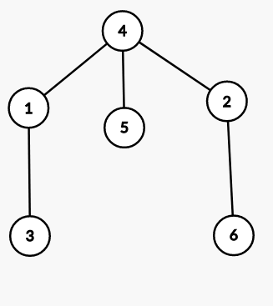
Sample Input 3 | Sample Output 3 | Sample Graph 3
13  1 2  1 3  1 4  4 5  5 6  5 7  7 8  8 9  9 13  6 10  10 11  11 12 | 12 13 | 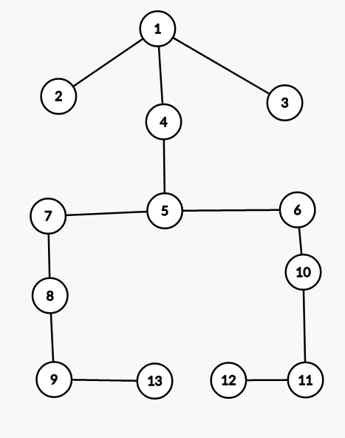

This problem may have multiple valid answers. However, make sure it satisfies the given condition.

Explanation:

In test case 1, if you choose city 2 and city 3, then the path will be
2 → 4 → 1 → 3. If you choose city 3 and city 5, then the path will be
3 → 1 → 4 → 5.
Since, in both paths you can visit a maximum of four cities by using the roads only one, both the answers are valid.

In test case 2, one can see that visiting from city 3 to city 6 ( or vice-versa) is only the valid answer. The path will be 3 → 1 → 4 → 2 → 6.

Bonus 2: Task 08:

As mentioned earlier, Dora is on a short trip and she is leaving the country. Before leaving the country, as a token of gesture, Dora gifted you with a problem this time, which you will find in this link in the lightoj, an online judge.

To open the gift, you have to create an account at lightoj first. [https://lightoj.com/]

Problem Link: https://lightoj.com/problem/back-to-underworld

